**Python FSD**

Capstone Project Solution

Online Banking Application – Phase 2



**Online Banking Application**

Backend 🡪 Python Django Rest API

Database 🡪 Mongo Db

Frontend 🡪 React JS

**Steps to be followed:**

1. Installing dependencies required for the project
2. Starting the MongoDB server and creating bankdb schema in MongoDB
3. Setting Python project
   1. Creating a workspace for VS Code
   2. Creating Virtual Environment
   3. Installing dependencies
   4. Creating a project in VS Code
   5. Creating an app within project
   6. Updating respective files for code
4. Setting Python project
   1. Creating workspace for VS code
   2. Creating React JS project
   3. Installing required dependencies for react js project
5. Interact react with python Django rest api

**Step 1: Installing dependencies required for the project**

1. Please ensure that the following tools are installed in your system:

* Python 3.x
* Visual Studio Code
* Django
* Django_rest_framework
* Djongo
* pymongo
* MongoDB
* Node JS
* React JS

1. Download the following GitHub repository:

https://github.com/Kaleakash/online-baking-application-using-react-python-django.git

**Please refer phase 2 folder with backend and frontend code**

**Step 2: Starting the MongoDB server and creating the bankdb schema in virtual lab**

* 1. Login the virtual lab with your login details.

Here I am using python lab.

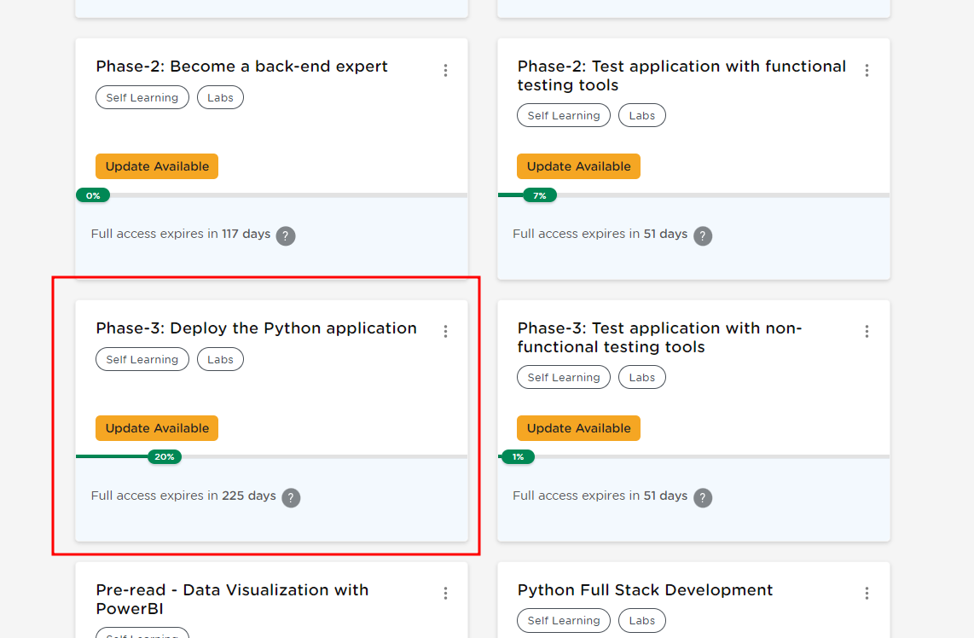

* 1. Open the terminal, and run the following command to check the MySQL server’s status:

**mongod --version**

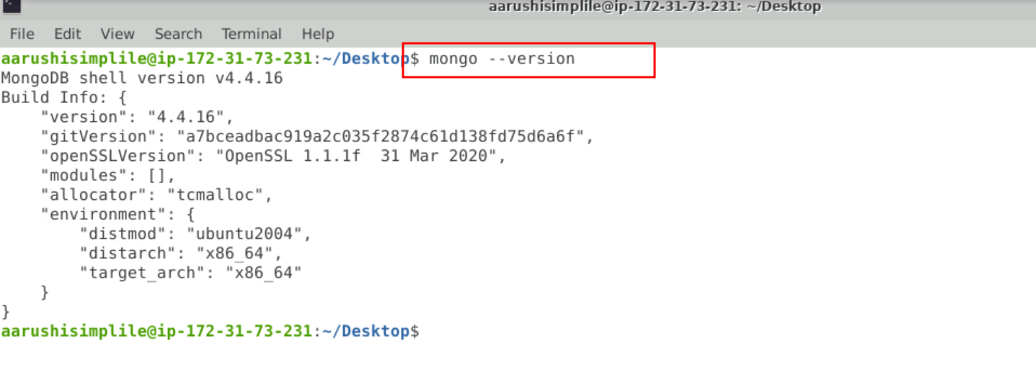

* 1. Run the following command to start the MongoDB server from the terminal

**sudo mkdir -p /data/db  
sudo mongod**

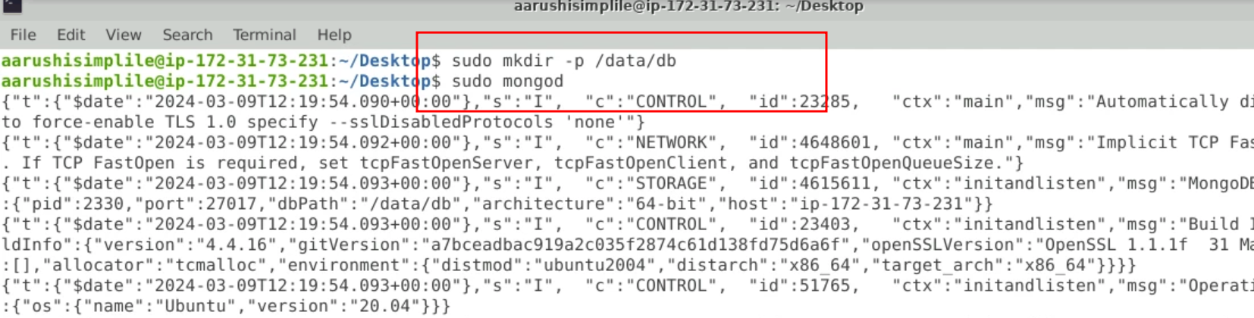

**If you are getting any error**

**Please remove the previous db file using below command**

**sudo rm -r /data/db**

NOTE: Do not close this terminal as this is the mongo server running.

In case getting /data/db error please execute the below command:

**sudo mkdir -p /data/db**

* 1. Open another terminal and use the following command to start the mongo shell:

**sudo mongo**

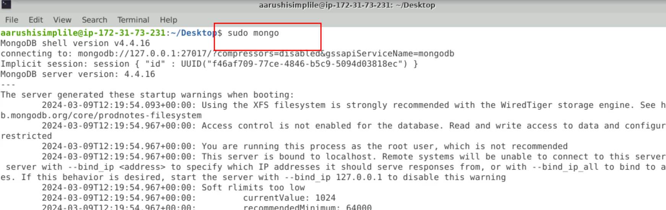

* 1. Once the mongo shell is up and running, run the below command to see existing databases:

**show dbs**

To create a database, execute the below command:

**use bankdb**

To see existing collections if any, execute the below command. It will be empty.

**show collections**

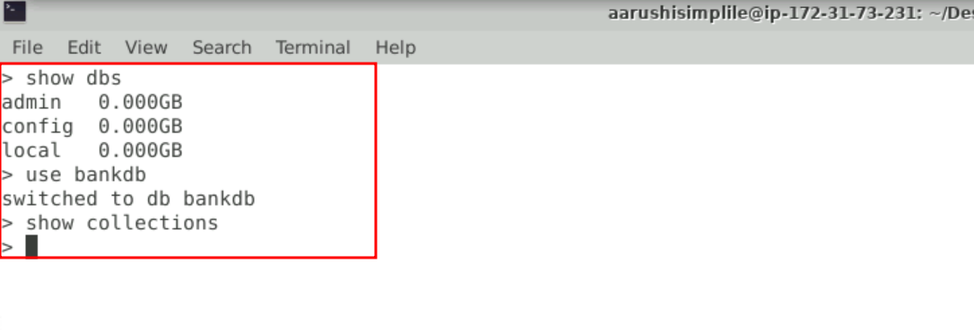

**Step 3: Now we create the environment for python to run the project.**

1. Create the folder as

**mkdir phase2-back-end-app**

1. Now we move inside this folder

**cd phase2-back-end-app**

1. Now we need to create python virtual environment and active the virtual environment

**python3 -m venv .venv**

**source .venv/bin/activate**

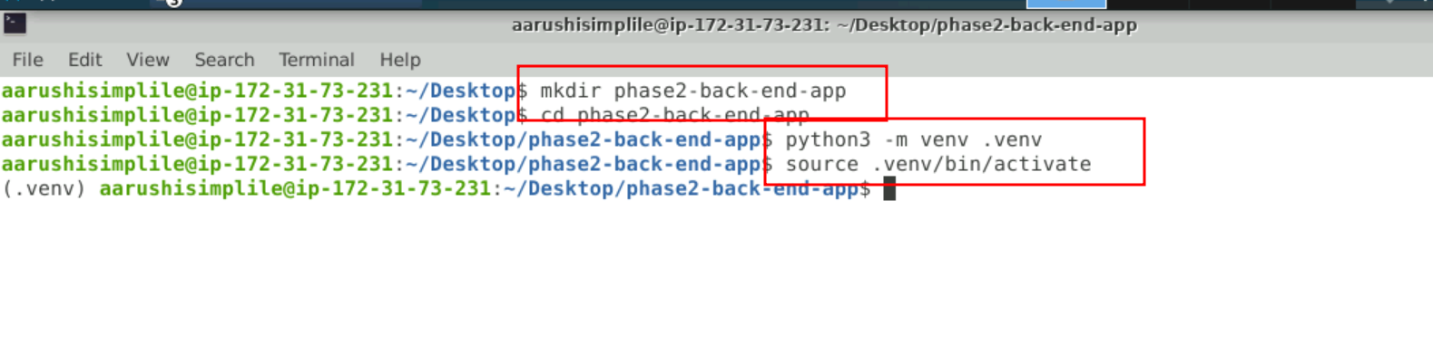

1. Open the VS code using the **code .**
2. Create the requirements.txt file which is responsible to install the require dependencies to run the application.

requirements.txt

Django == 3.0.6

djangorestframework==3.12.4

Markdown==3.3.6

django-filter==21.1

djongo

pymongo==3.12.3

sqlparse==0.2.4

django-cors-headers==3.10.1

#setuptools

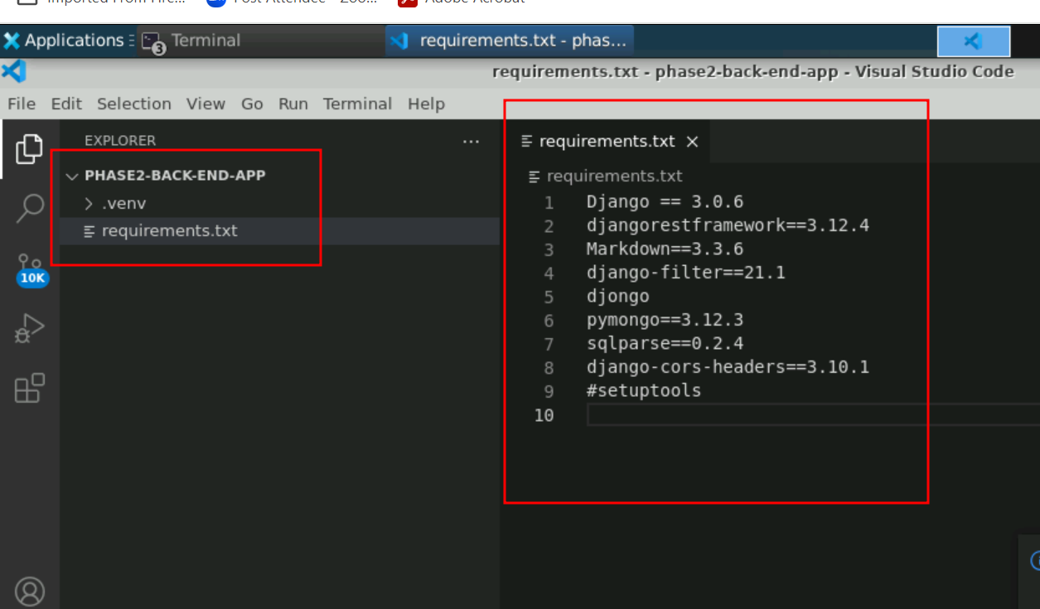

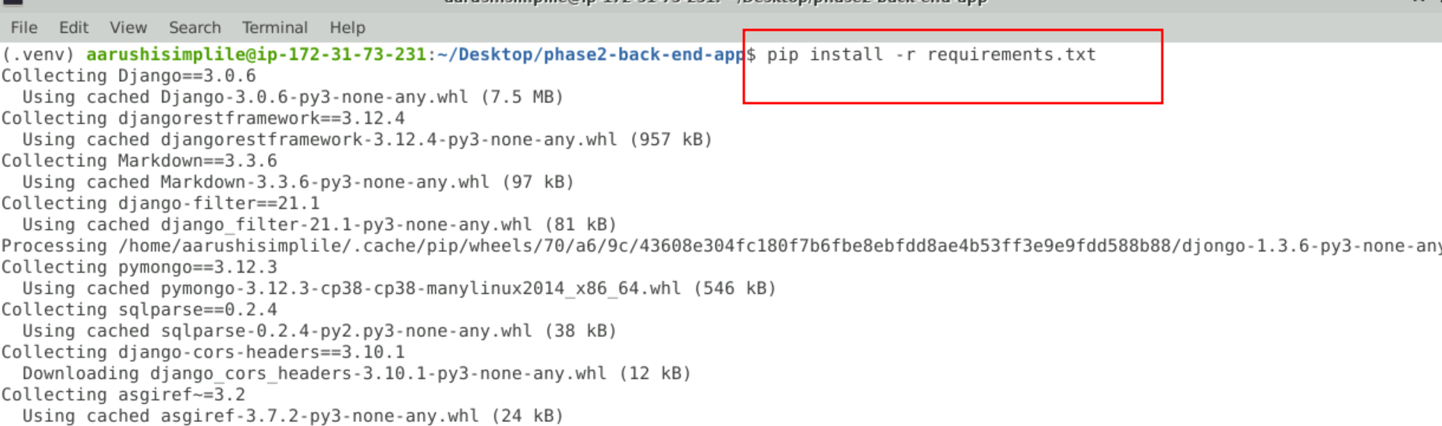

**Step 3: Now we need to create the project**

* 1. Check the django-admin version as follows:  
     **django-admin version**

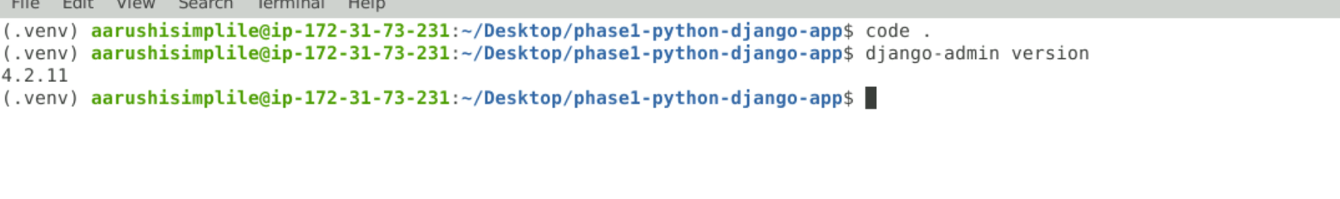

* 1. Create a Django project by executing the below command:  
     **django-admin startproject backendrestapi**

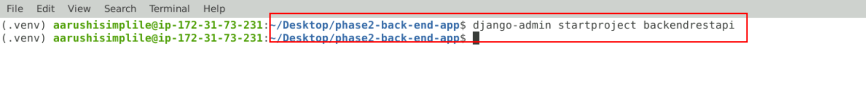

* 1. Execute the project by entering the phase1bankingapp folder and executing the commands below. The server should be up and running and the project available at **localhost:8000** as follows:

python manage.py runserver

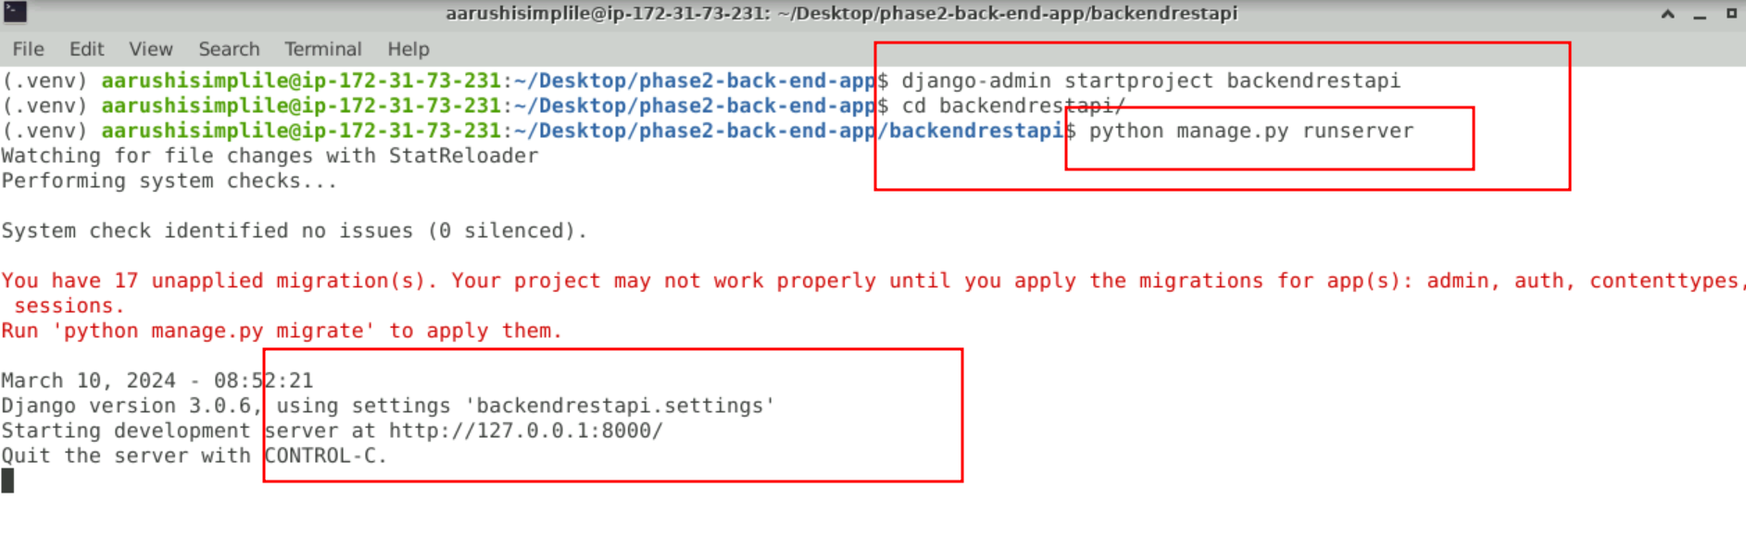  
  
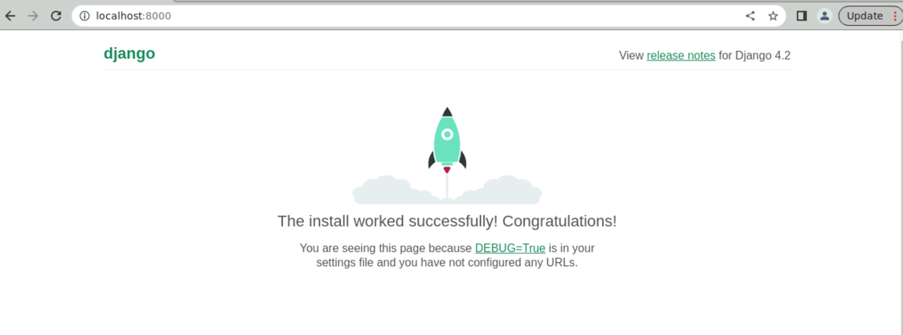

* 1. Now Hit Cntr + C to terminate the application
  2. Now we will create the app inside the project as It will create an app within the package explorer:  
     **django-admin startapp api**

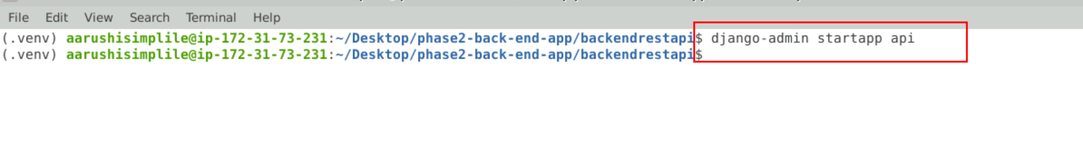

3.6 view the project structure in VS code.

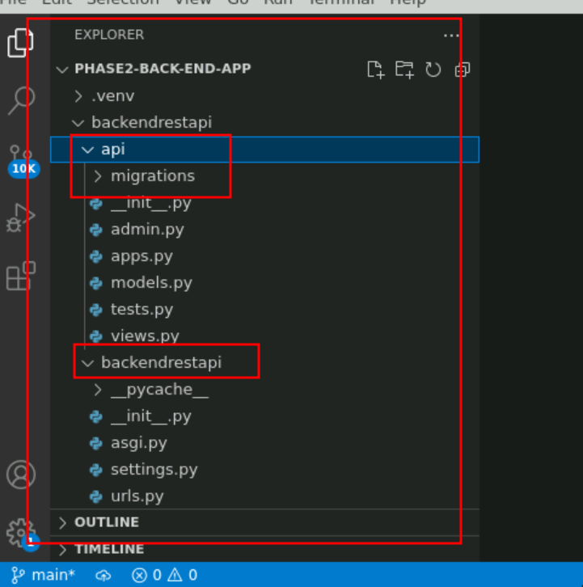

* 1. Make changes in the settings.py files for database configuration, adding apps and the authentication framework as follows:

In Installed_app section

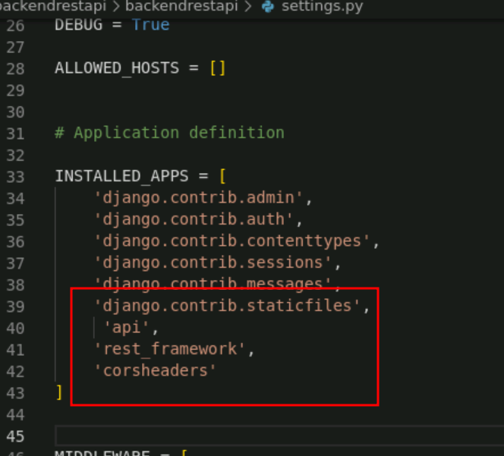

**In middleware section we need to add the cors middleware**

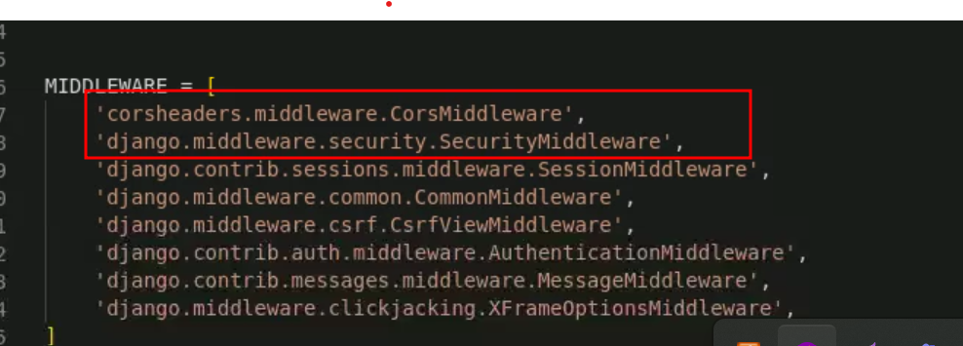

**Add this code to allow frontend technology to communicate python rest api**

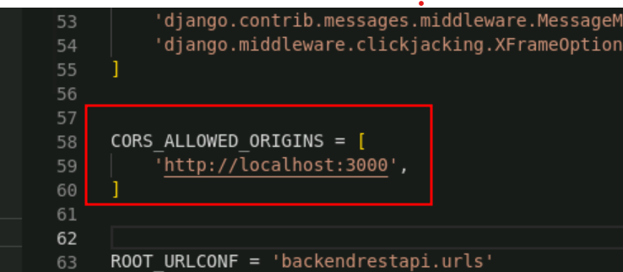

**Now we need to write the database details**

**By default Python Django use SQLite database**

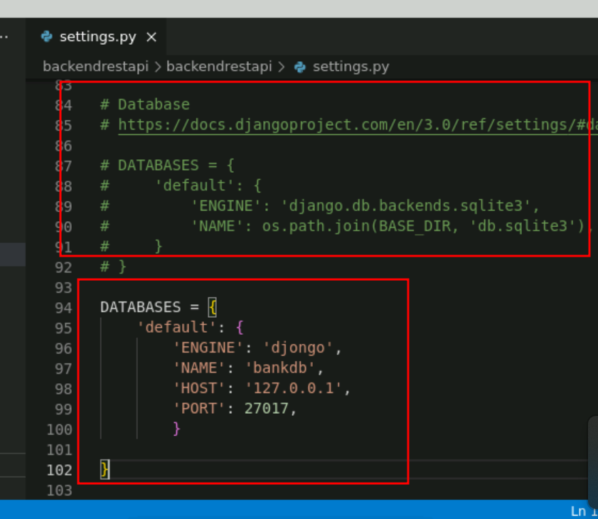

* 1. Create urls.py and serializers.py files within the api folder as follows:

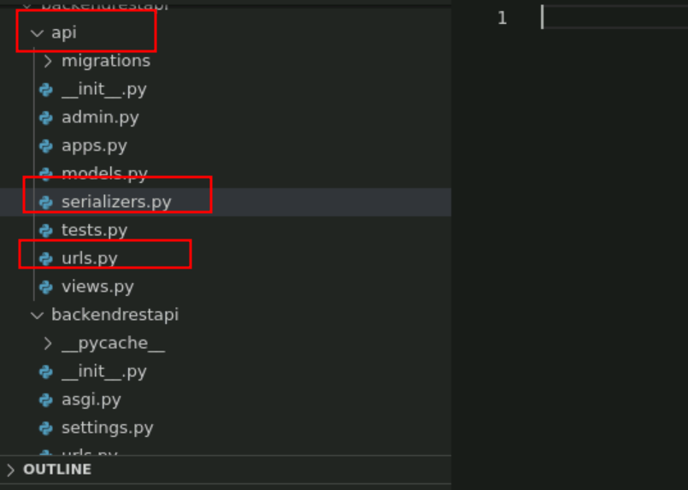

* 1. Update **models.py, urls.py, serializer.py, admin.py,vews.py** in bankapi app for your project

(Refer to GitHub repo for code for phase2 backend folder code from api app (directory) )

**views.py file**

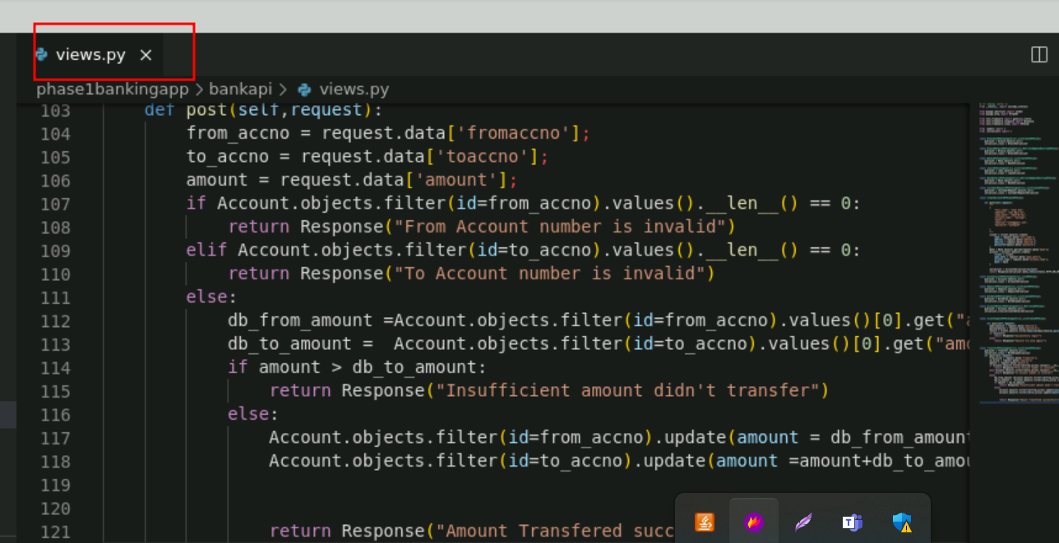

**urls.py**

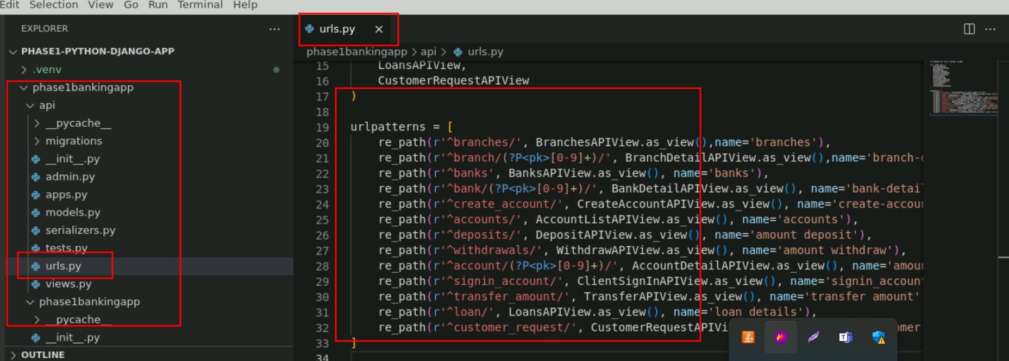

**serializer.py file**

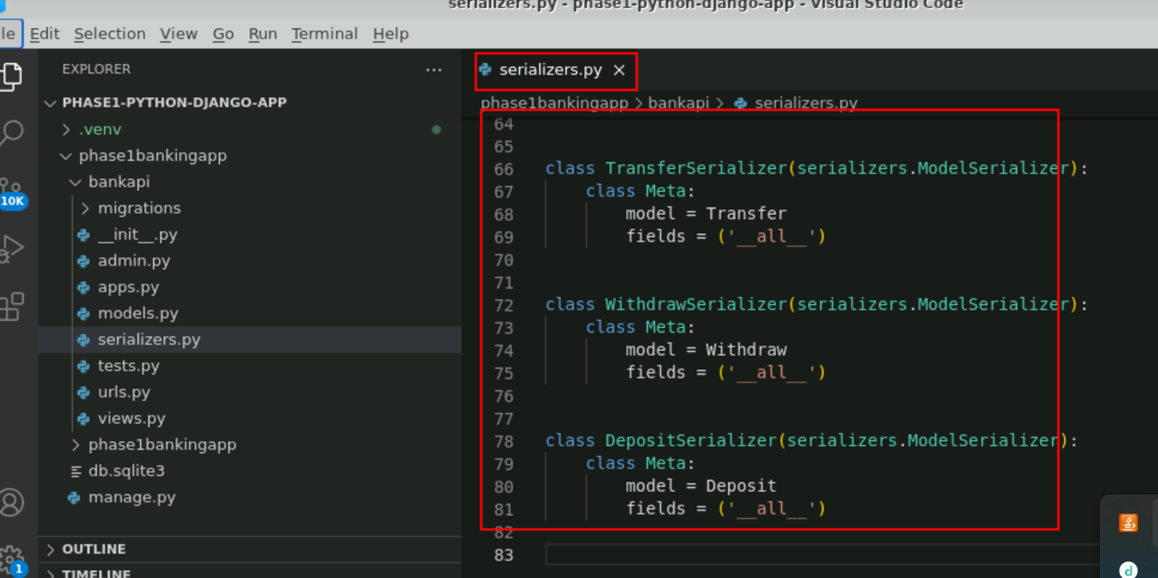

**models.py**

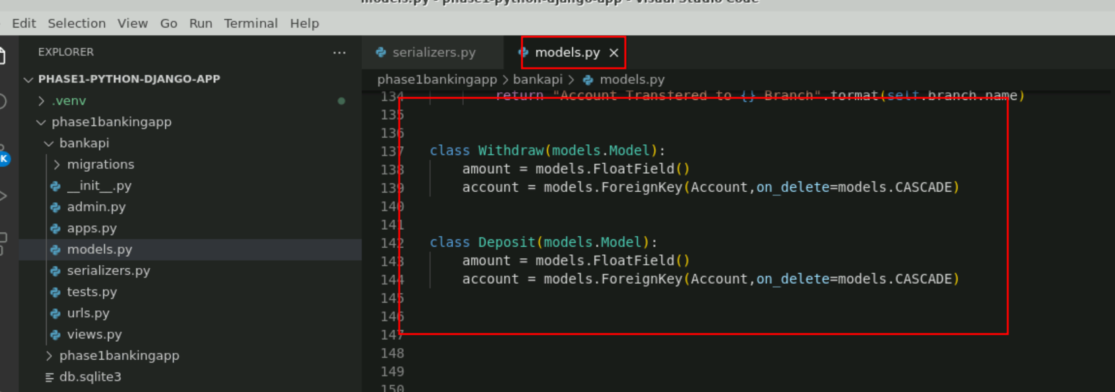

**admin.py**

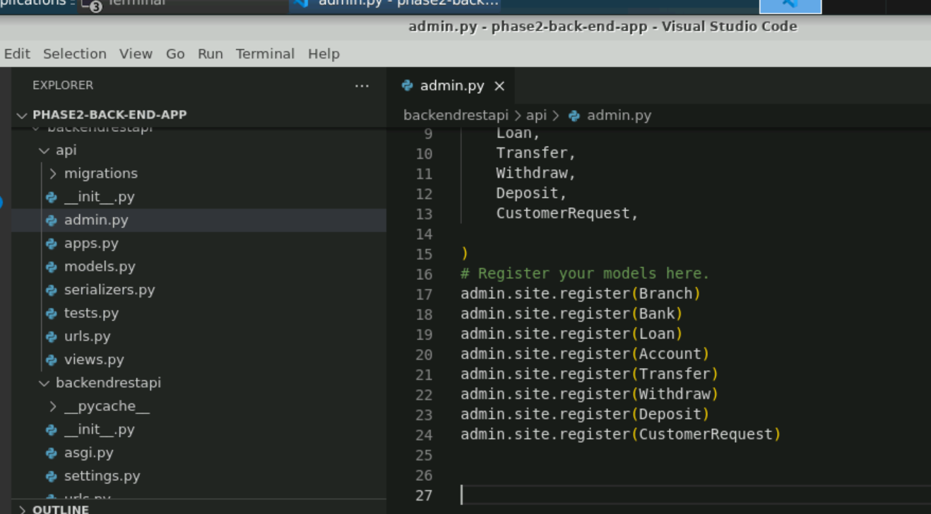

* 1. Now we need to provide the main path in url.py file part of **phase1bankingapp** folder

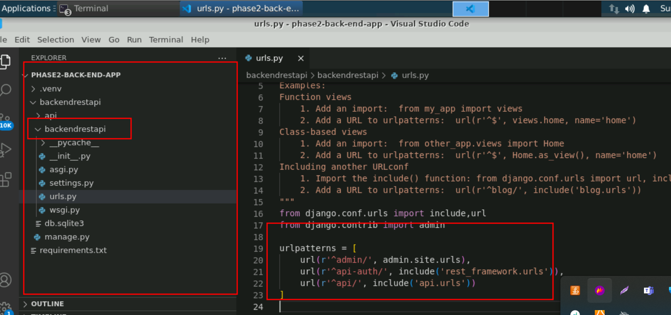

**Note** : Please refer phase2 backend folder project for all the python code.

* 1. Run the below commands to migrate models to the database   
     **python manage.py makemigrations**

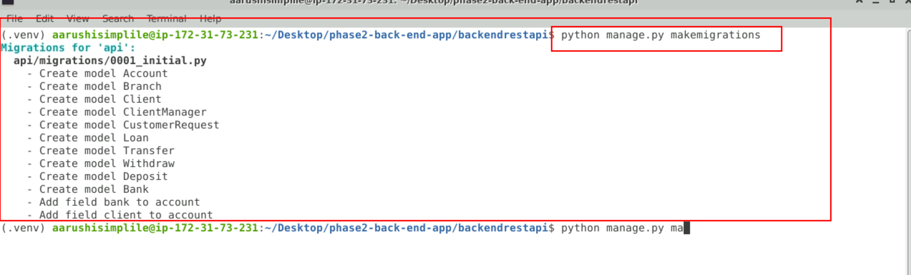

**python manage.py migrate**

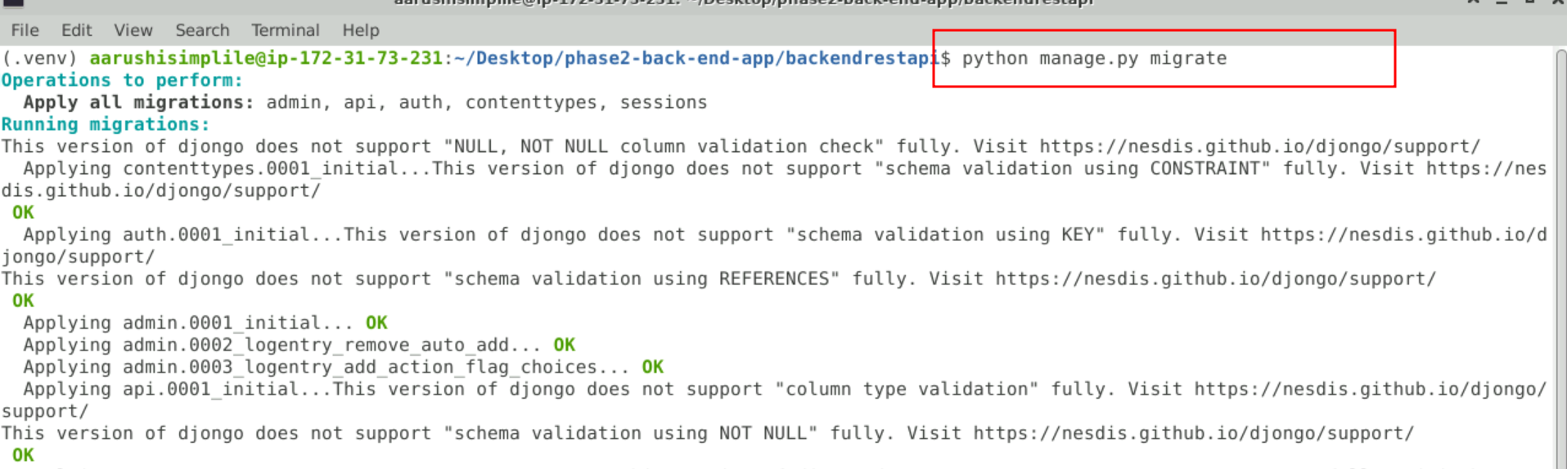

* 1. Check Mongo shell for the collections created mapping with the models

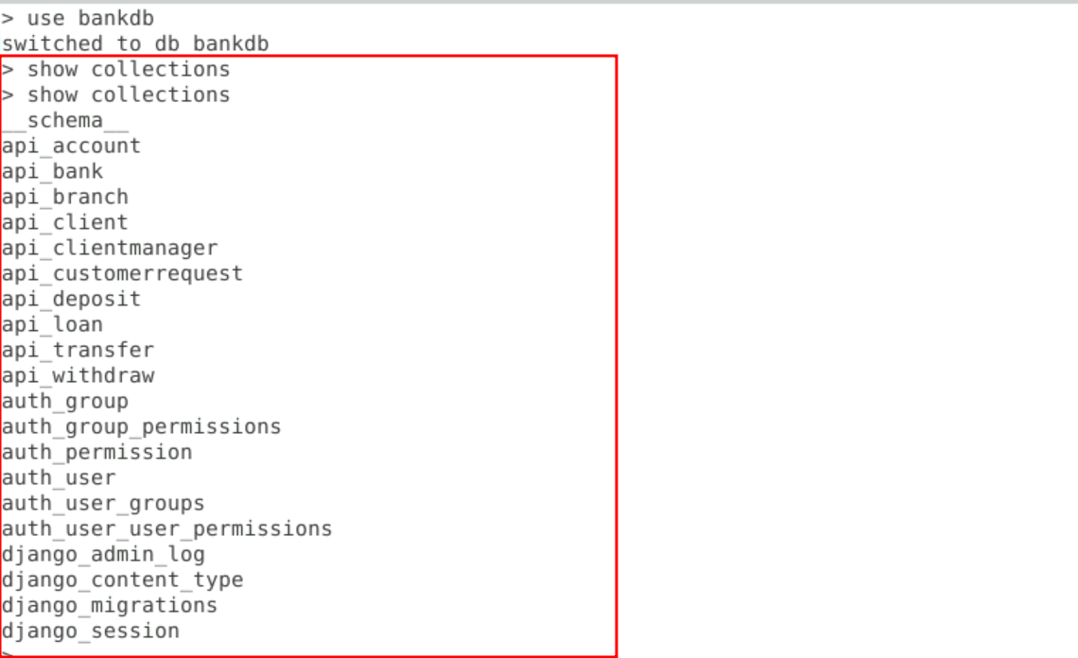

* 1. See the output on the browser as follows:

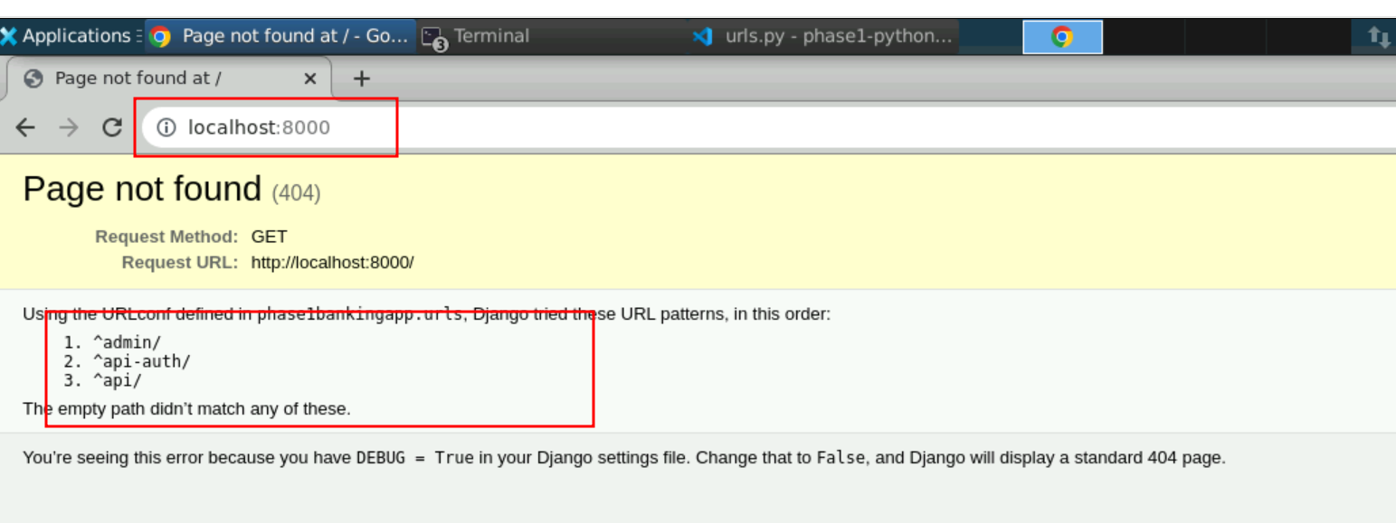

* 1. Now we will create the admin account. Django provided by default admin account which help to create the admin related task.

We need to enable the superuser user

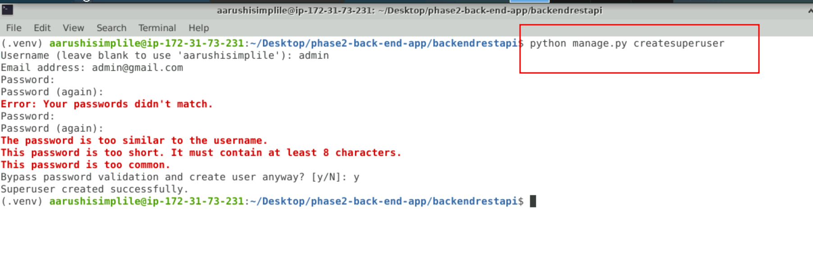

* 1. now once again run the application using below command as

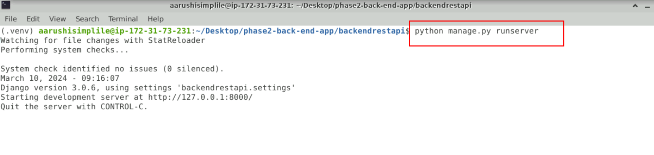

3.16: now open the below URL on browser.

<http://localhost:8000/admin>

the below page open

username is : admin and password is : admin

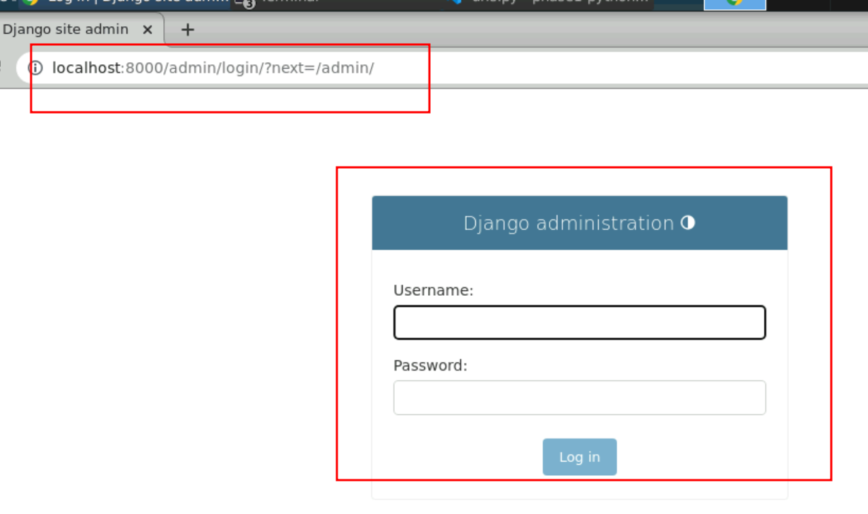

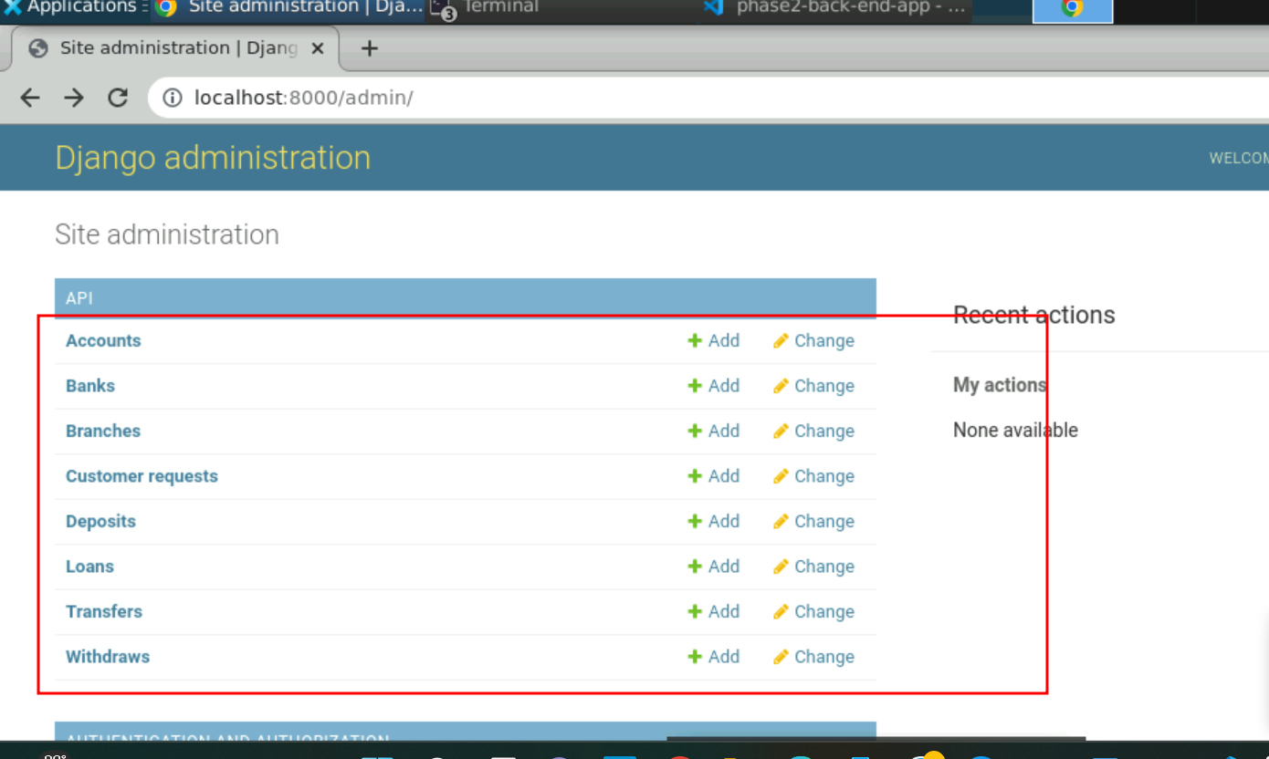

3.18 Now admin add the branches and bank details using GUI base provide by Python Django

Adding branches

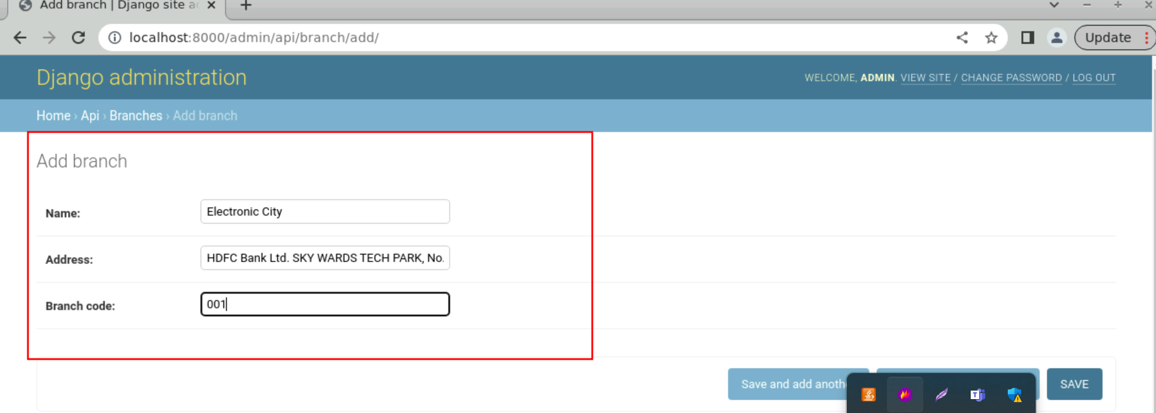

After added few branches

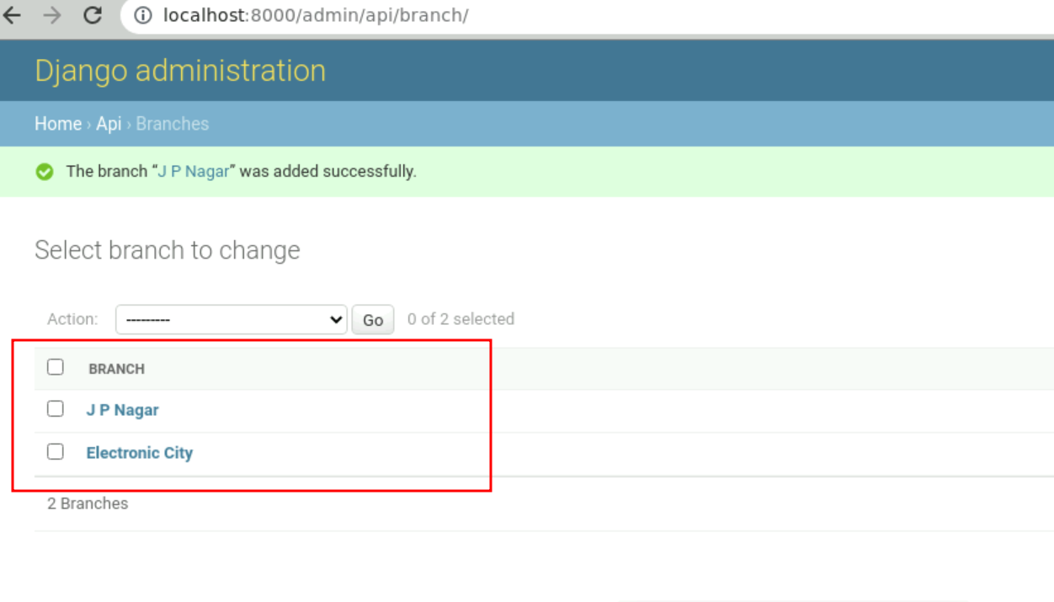

Now we will add the banks

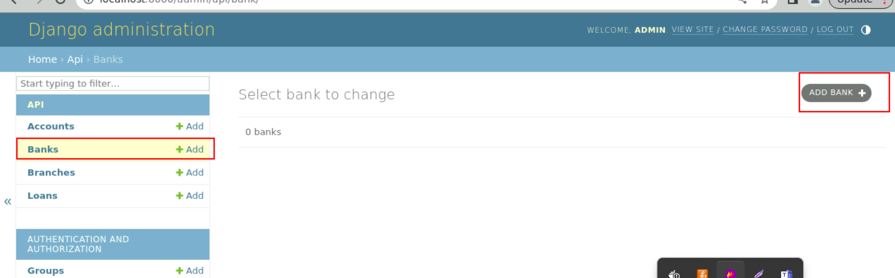

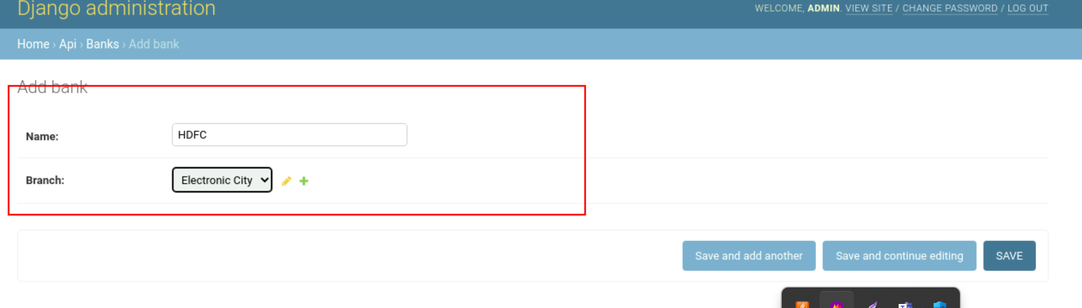

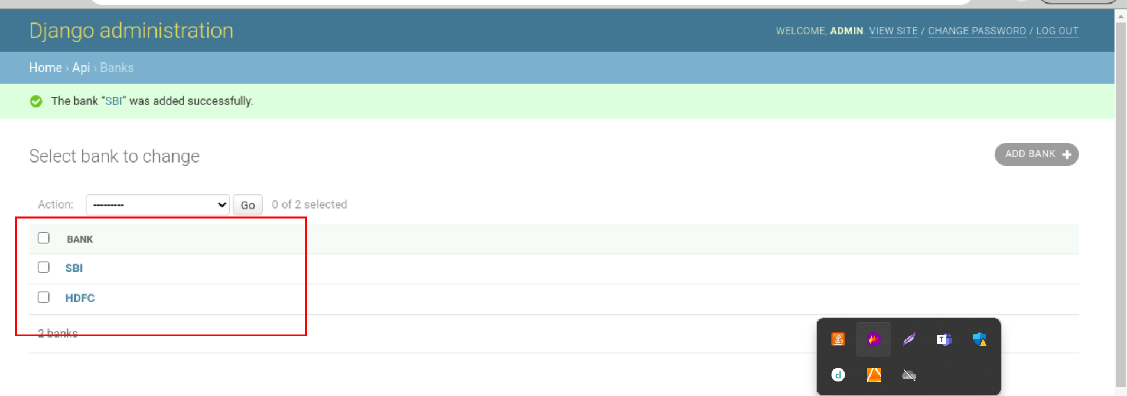

**Step 4: Now we need to create the React JS Project**

1. create the folder and move inside the folder

**mkdir phase2-front-end-app**

**cd phase2-front-end-app**

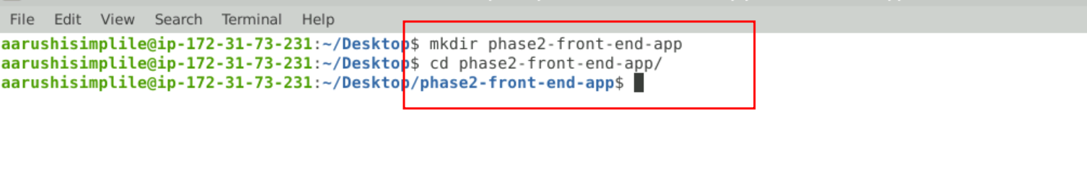

1. Now check the node js software and installed react js tools.

node --version



Now we need to install the react js

**sudo npm install -g create-react-app**

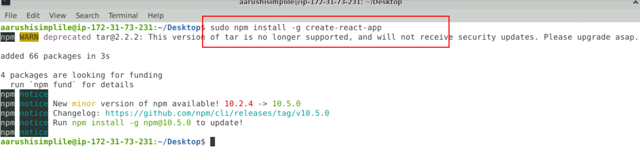

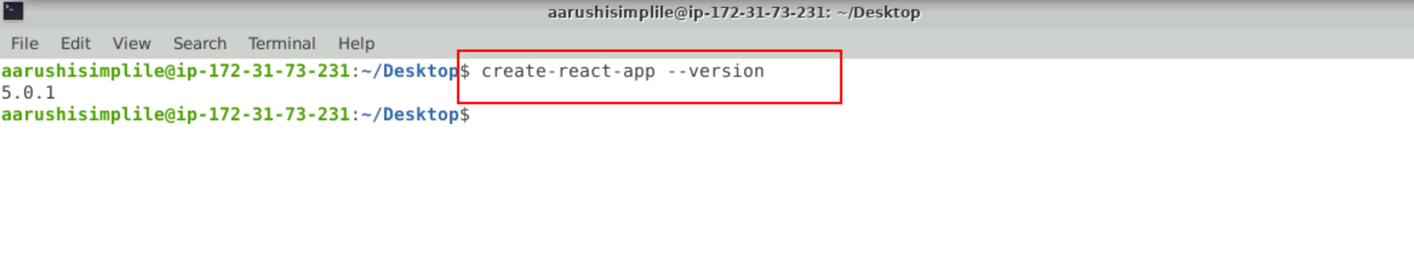

4.3 Now we will create the react-js project.

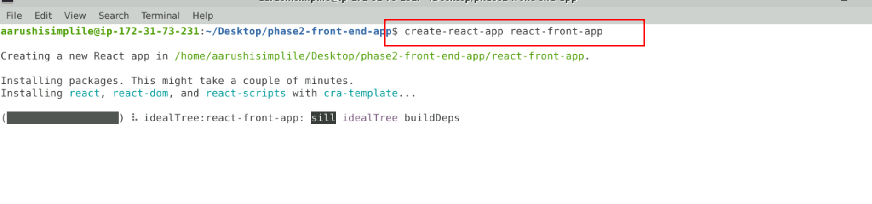

Mode inside react js project

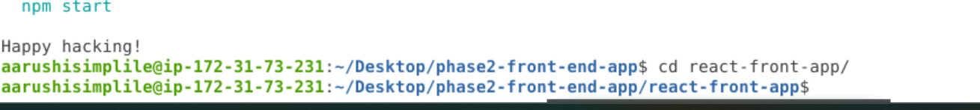

Please remove node_module folder from project.

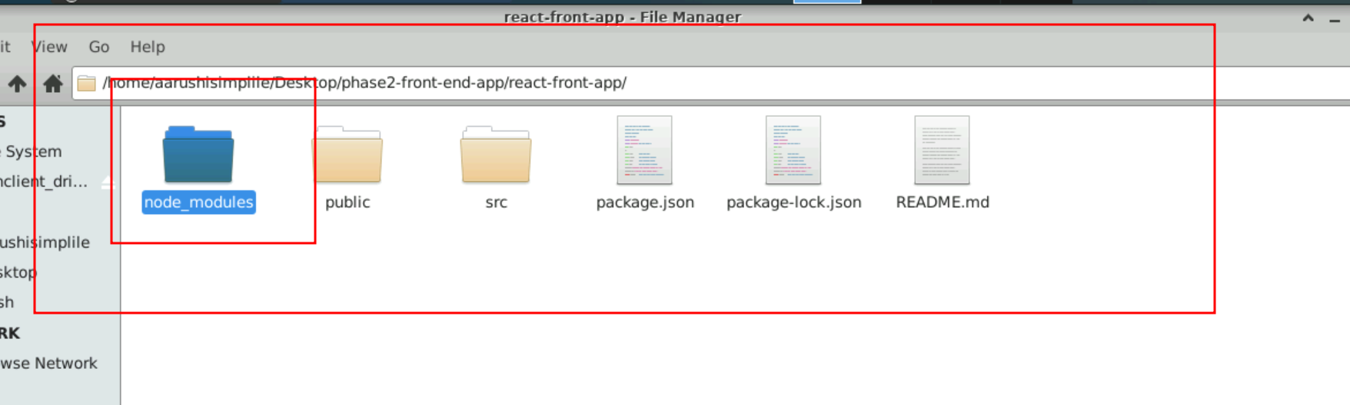

Open the project in VSCode.

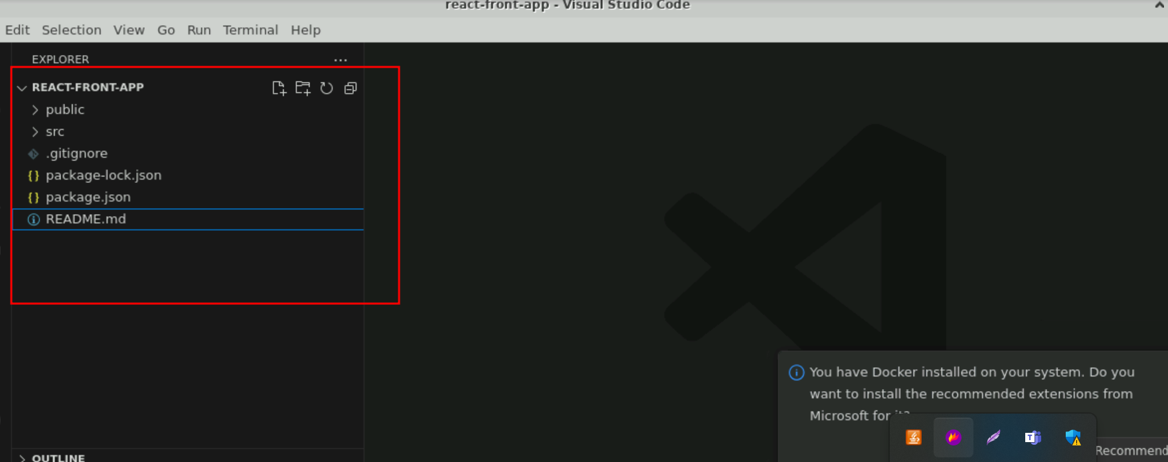

Now open the package.json file

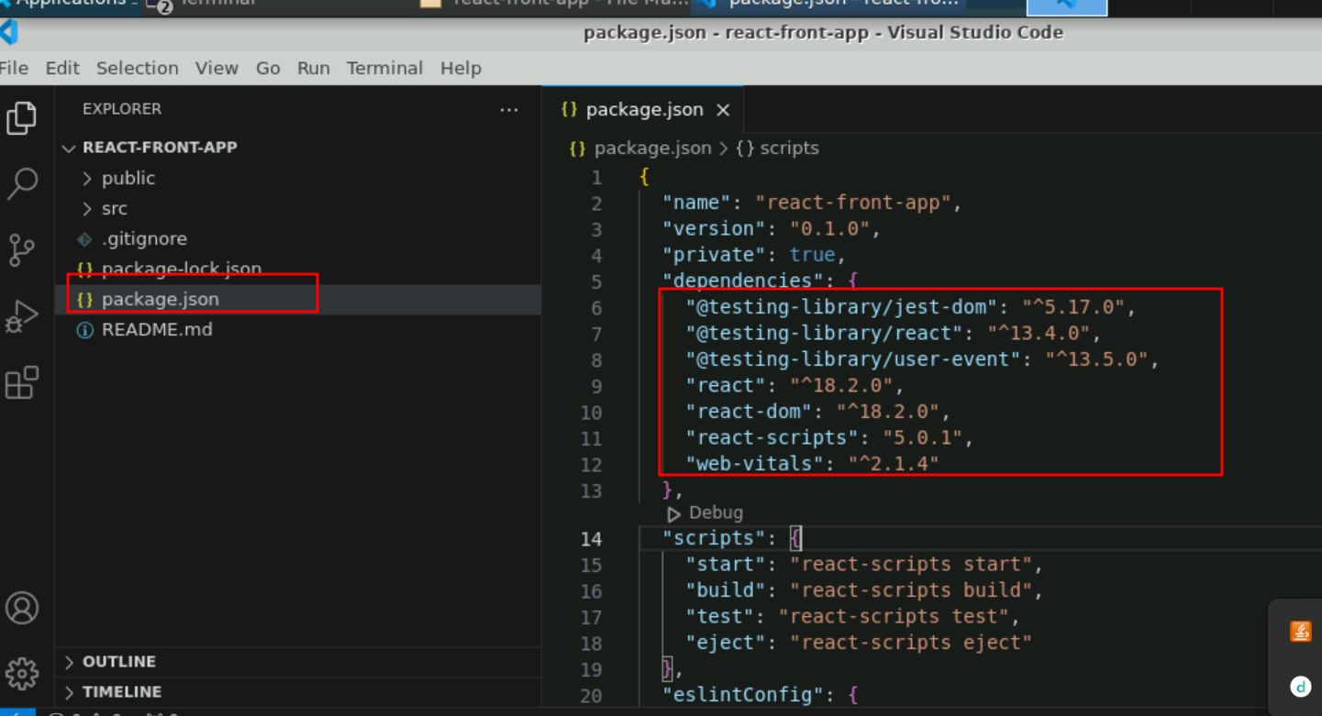

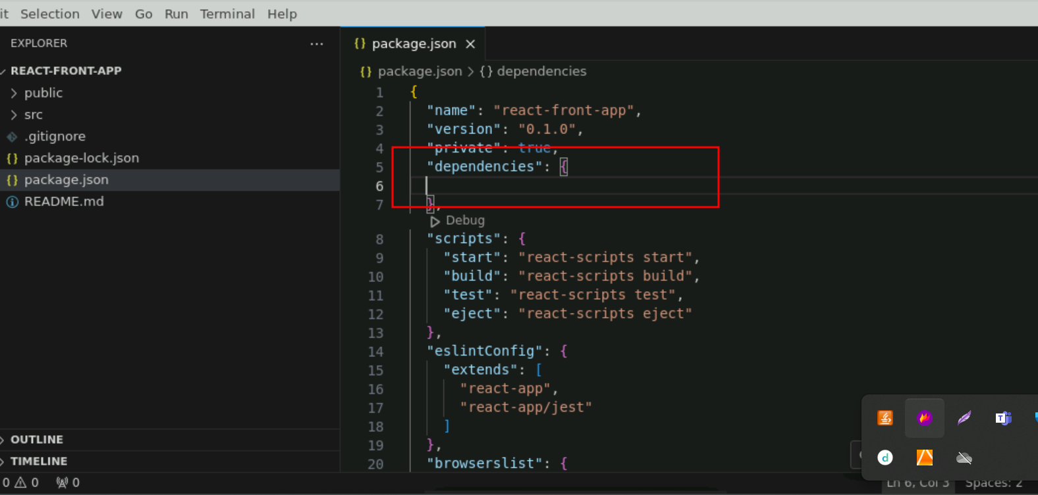

Remove all dependencies code and copy/paste from github phase2 frontend package.json dependencies code.

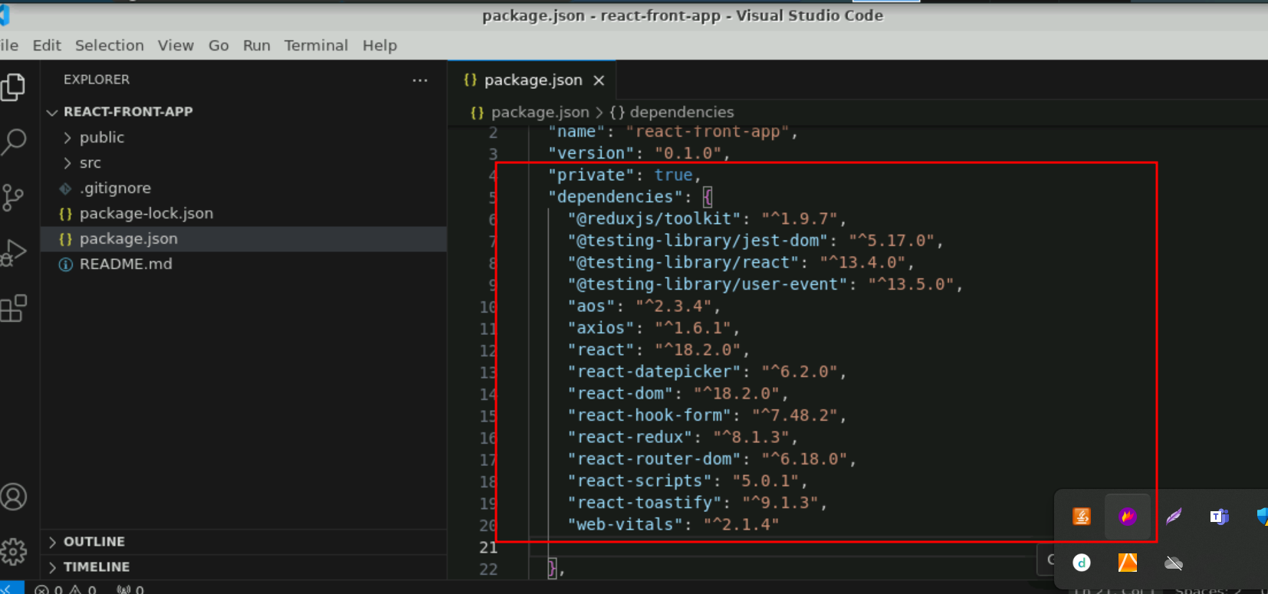

Now run the npm install command in terminal to install all required dependencies present in package.json file

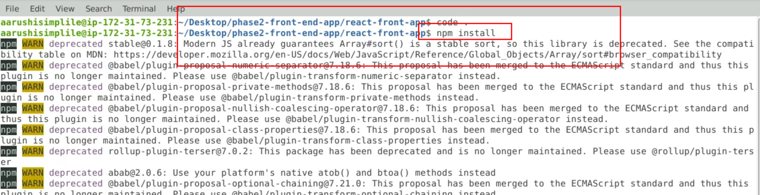

Please test the application working or not using **npm start** command

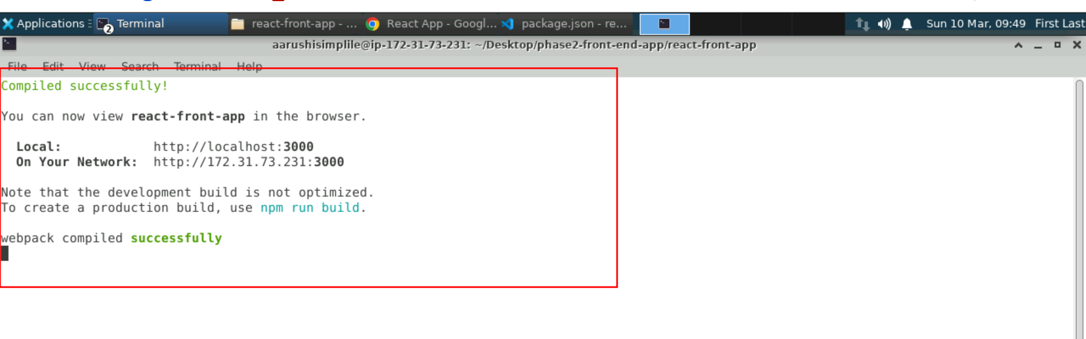

Open the browser.

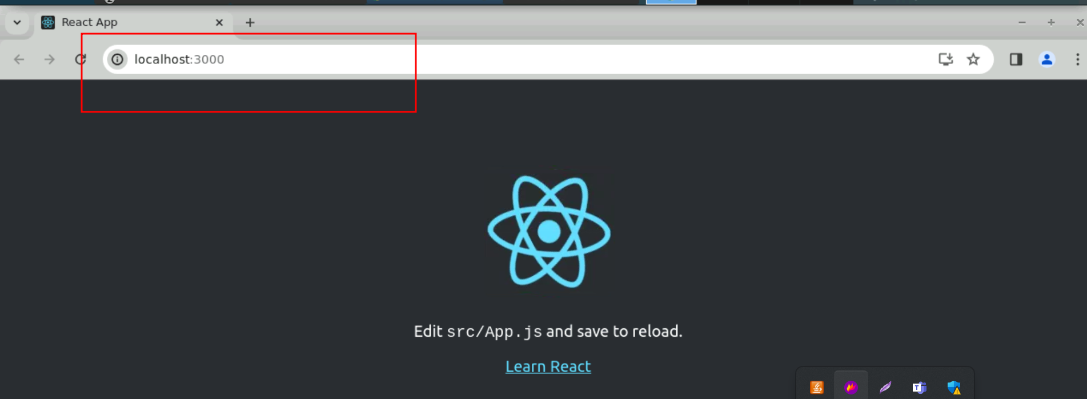

1. View all Branches details

**Method : Get**

**URL as** <http://localhost:8000/api/branches>

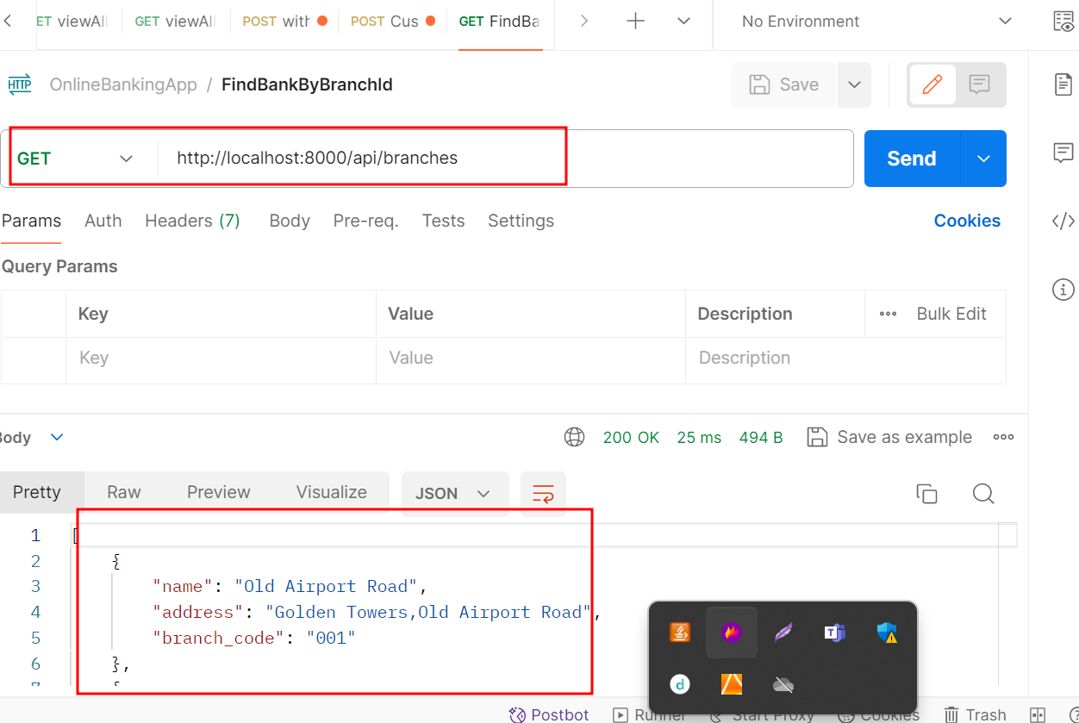

1. View all Bank details

**Method : Get**

**URL as** <http://localhost:8000/api/banks>

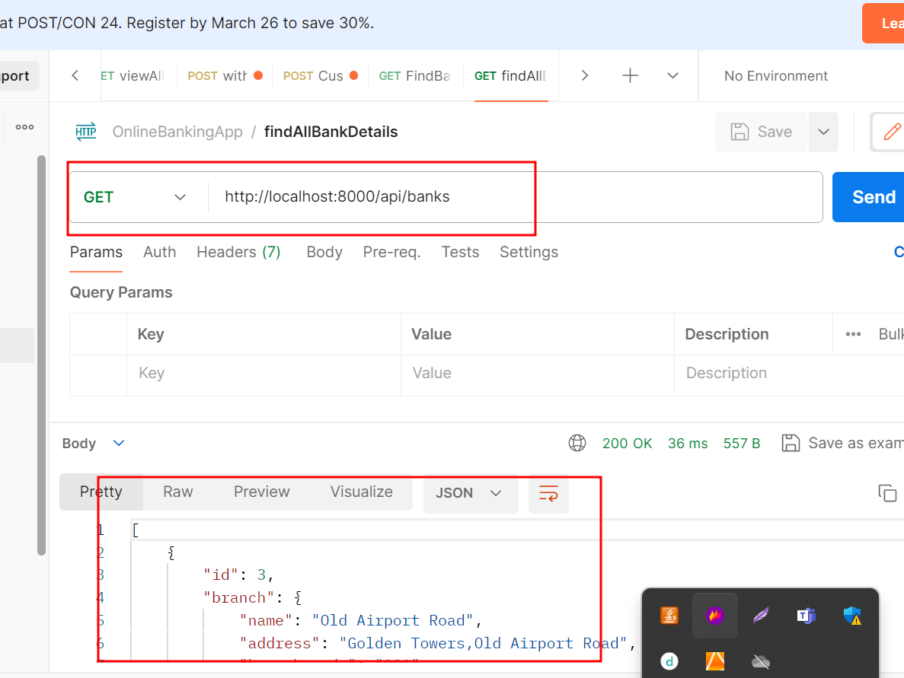

1. Create account

**Method : Post**

**URL as** <http://localhost:8000/api/create_account/>

**Header you need to set the option**

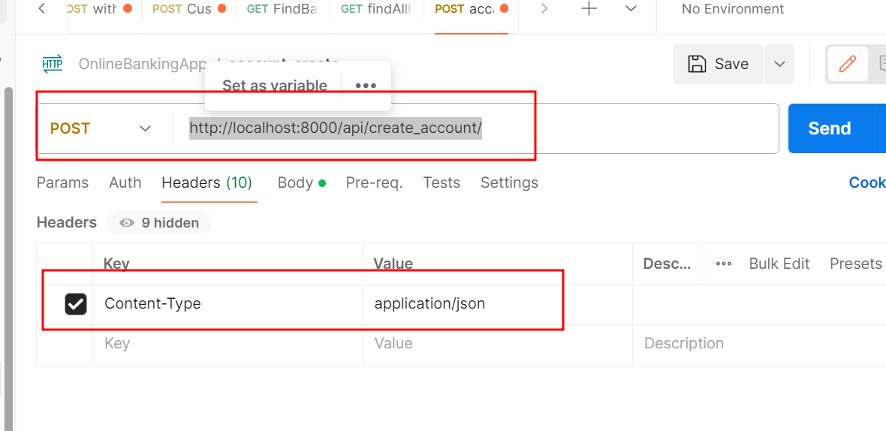

**In Body you need to pass the data**

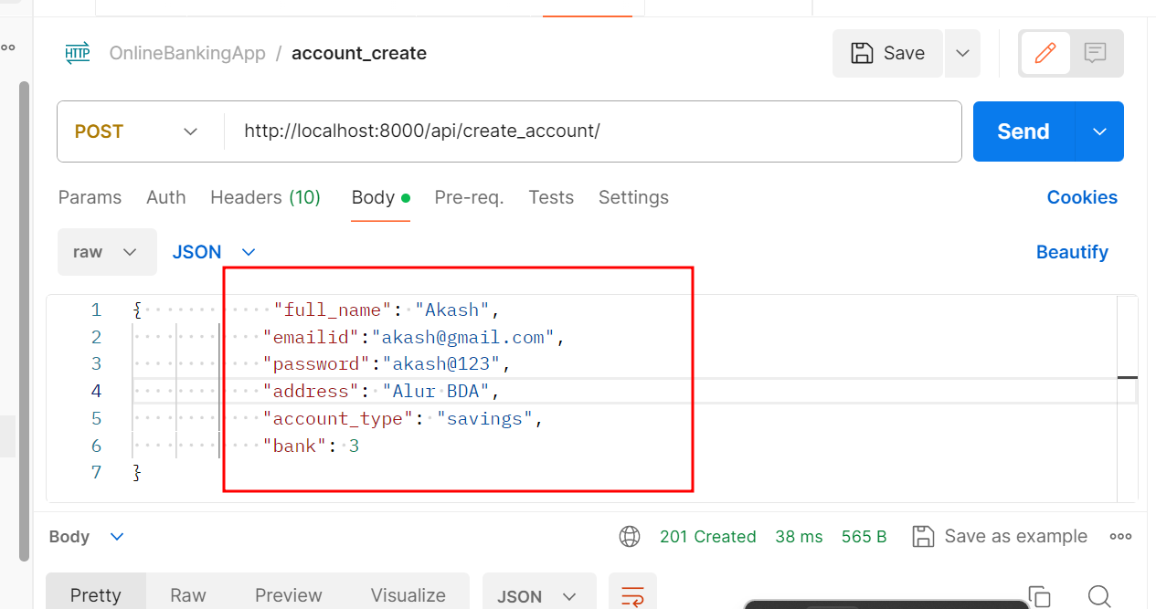

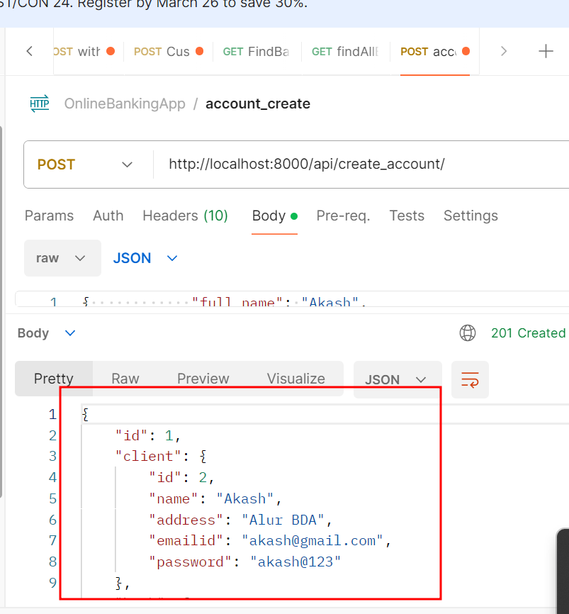

1. Find all account details

**Method : Get**

**URL as** <http://localhost:8000/api/accounts>

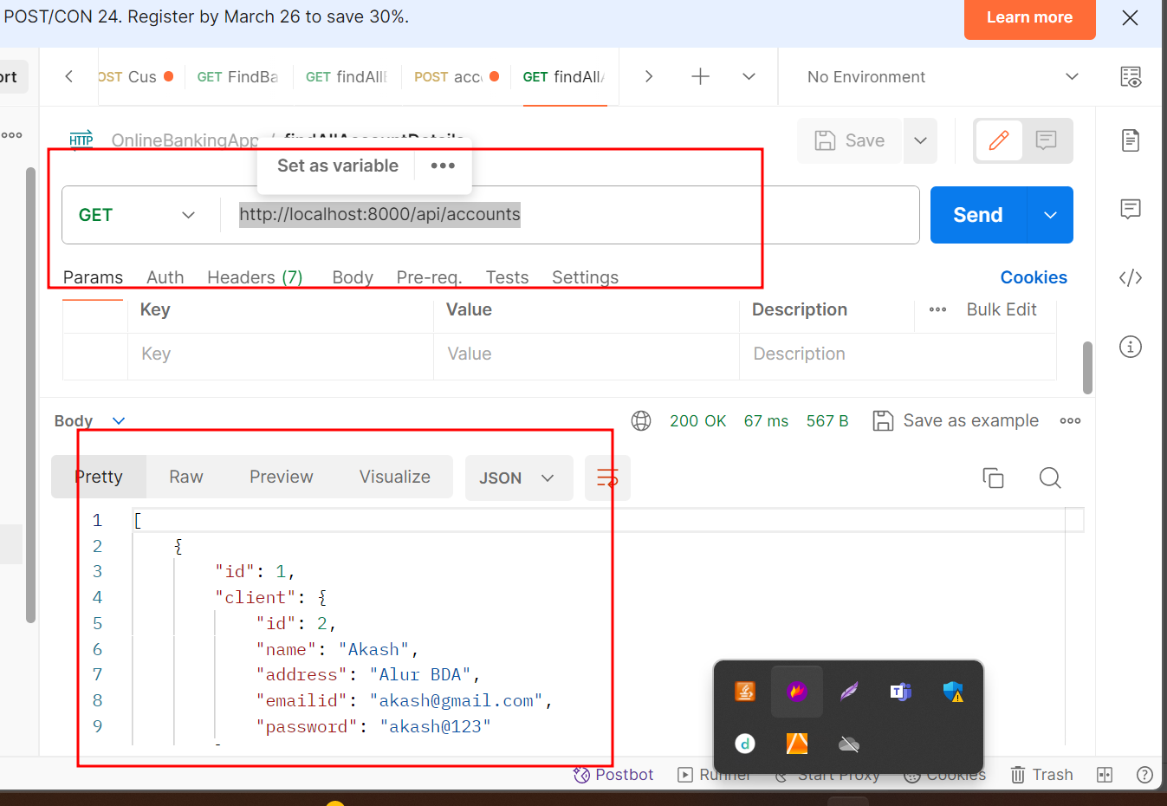

**4.6 Deposit the amount the account**

Method : Post

Header Content type : application/json

URL : <http://127.0.0.1:8000/api/deposits/>

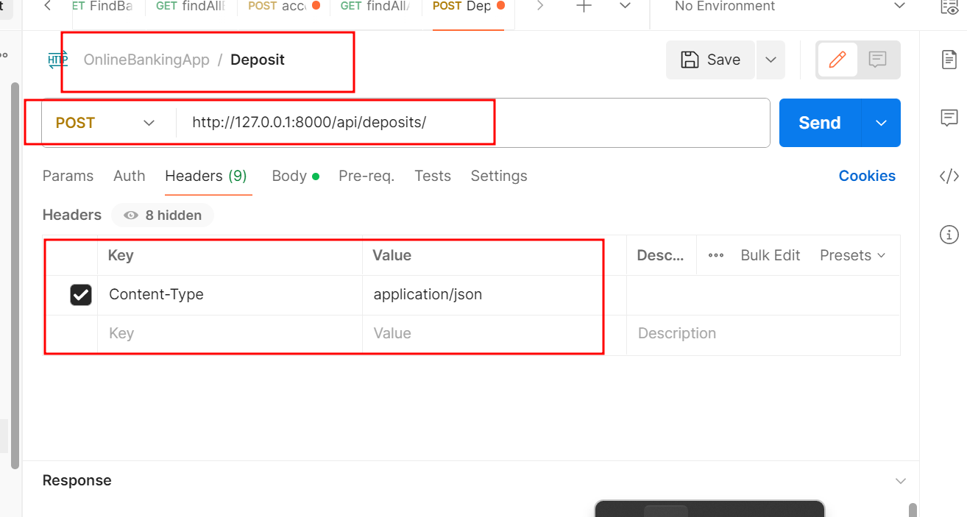

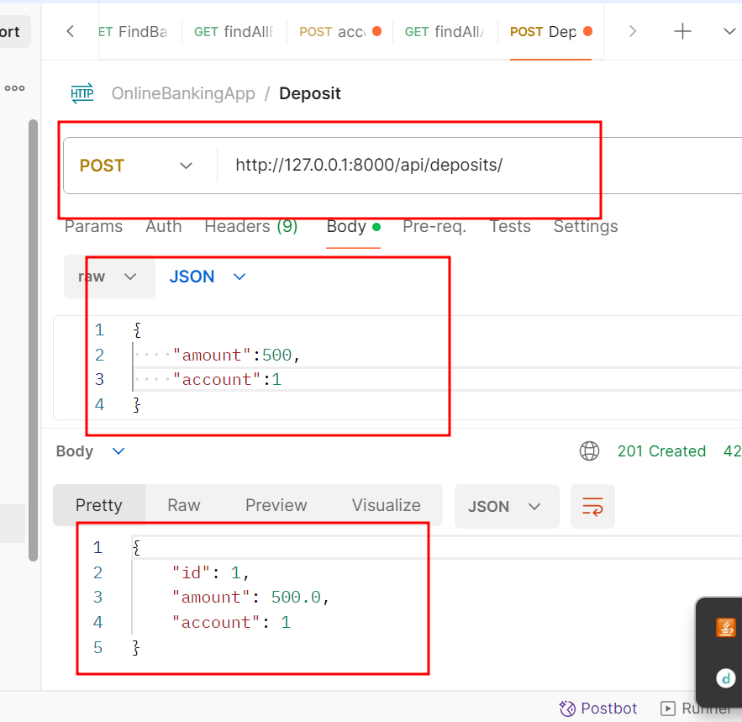

**4.7 : Withdrawn amount**

Method : Post

Header Content type : application/json

**URL :** <http://127.0.0.1:8000/api/withdrawals/>

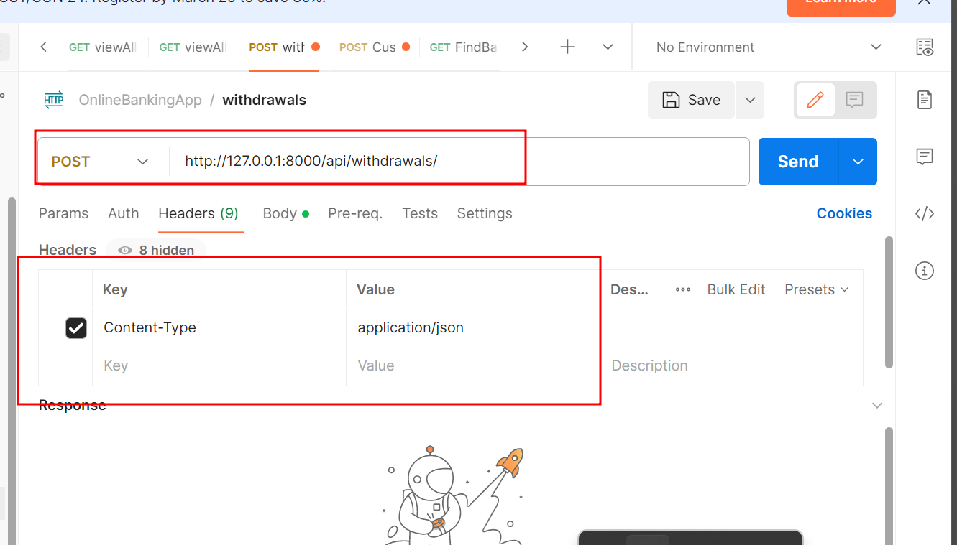

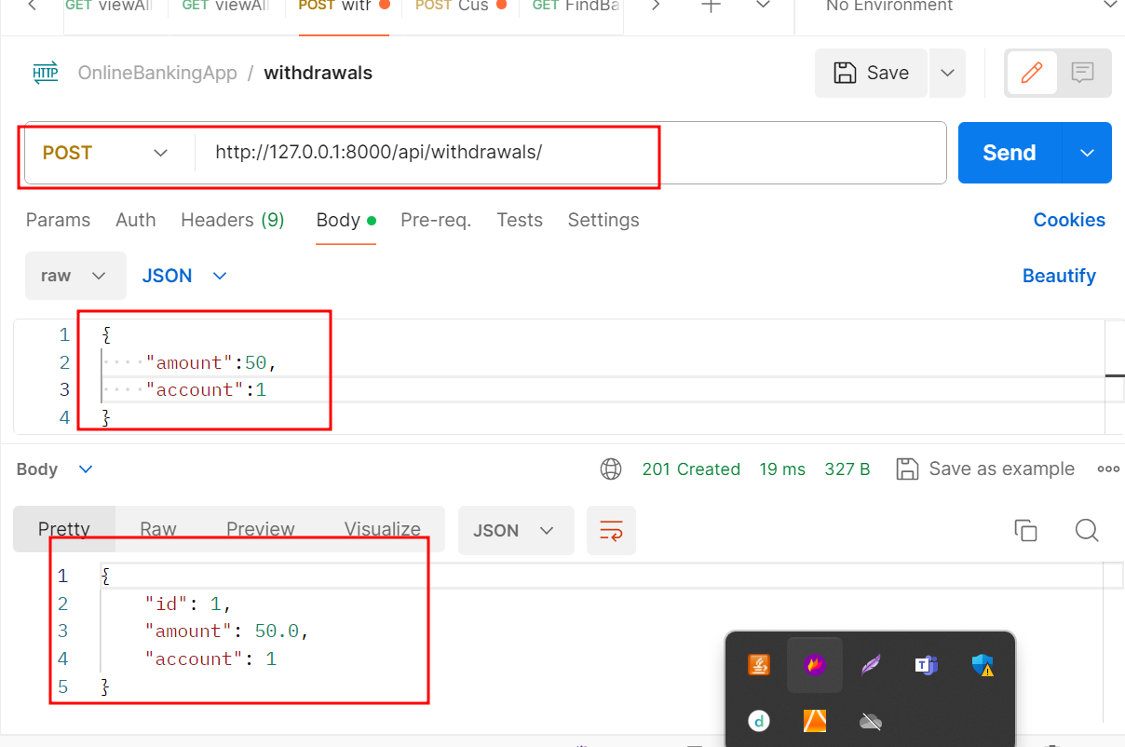

**4.8 : View all customer deposit info**

Method : Get

**URL :** <http://127.0.0.1:8000/api/deposits>

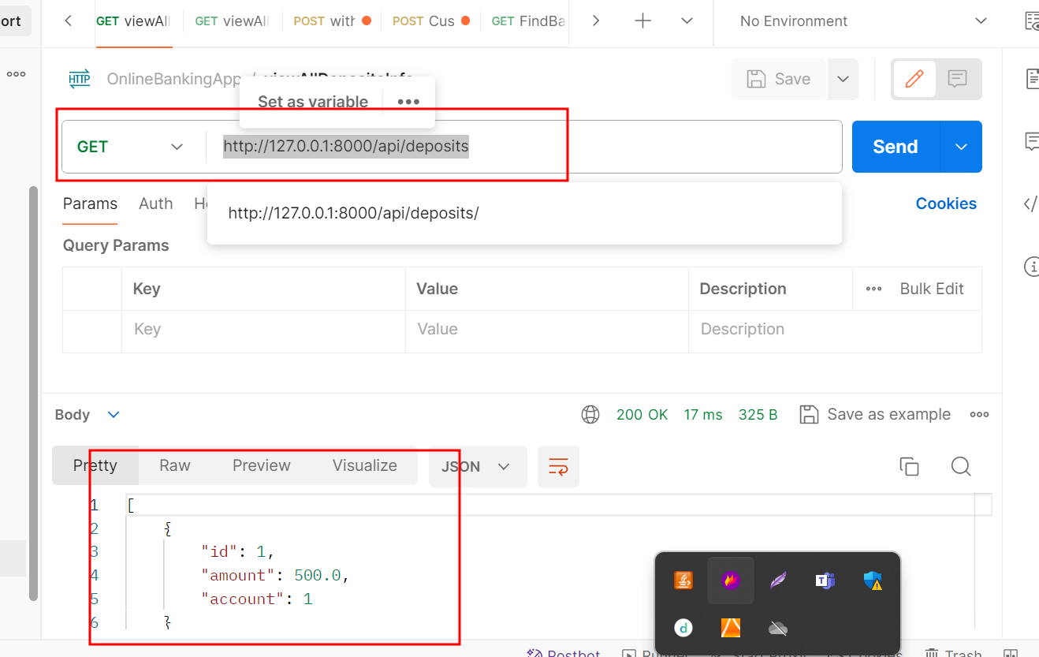

**4.8 : View all customer withdrawn info**

Method : Get

**URL :** <http://127.0.0.1:8000/api/withdrawals/>

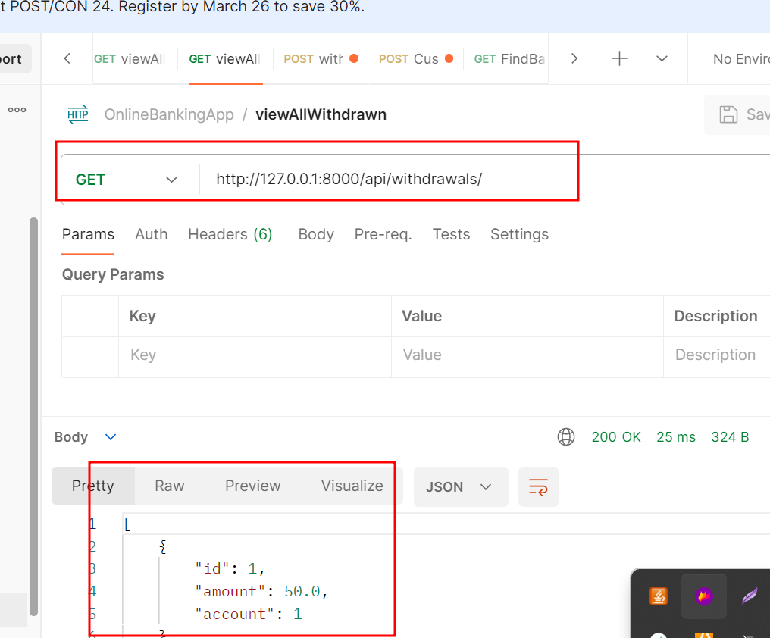

**4.9 : View transfer amount**

Method : Post

**URL :** <http://127.0.0.1:8000/api/transfer_amount/>

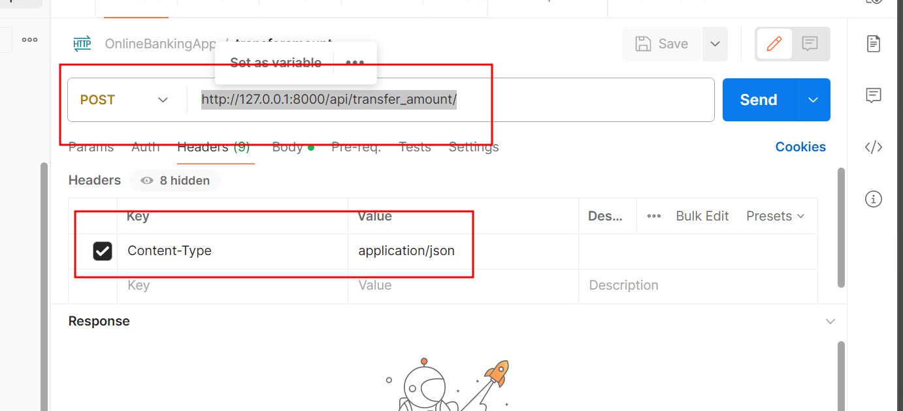

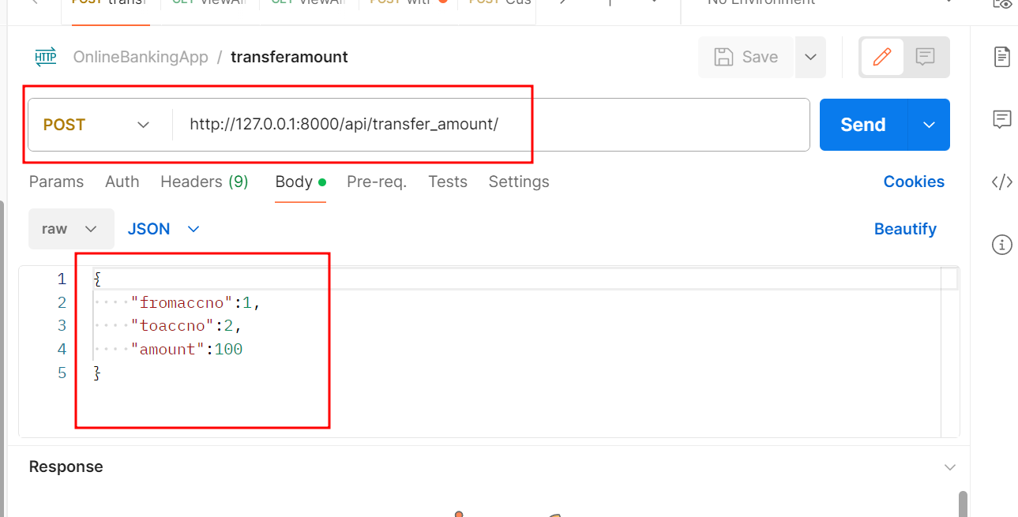

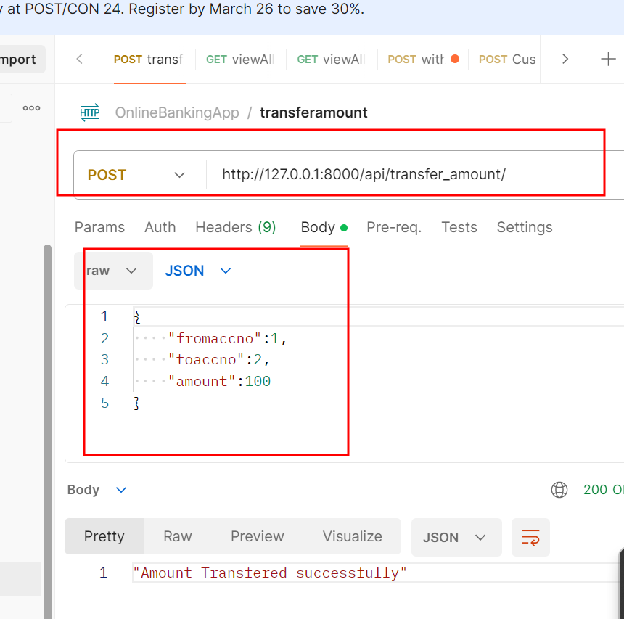

**5.0 : Customer request for different type of service**

Method : POST

**URL :** <http://127.0.0.1:8000/api/customer_request/>

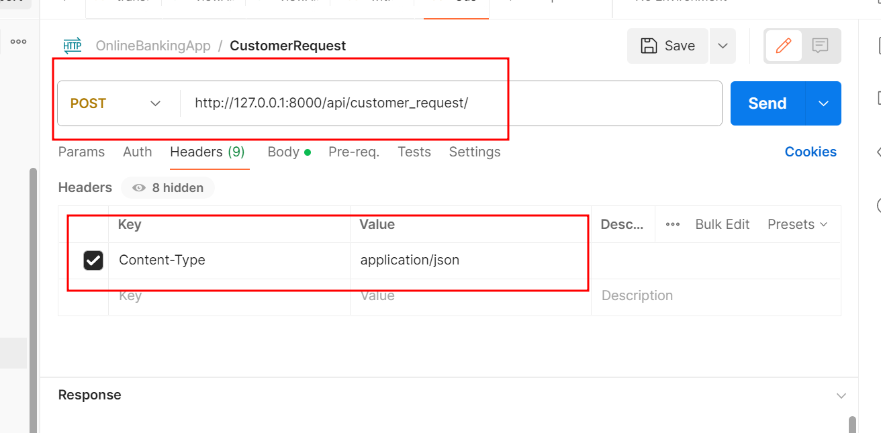

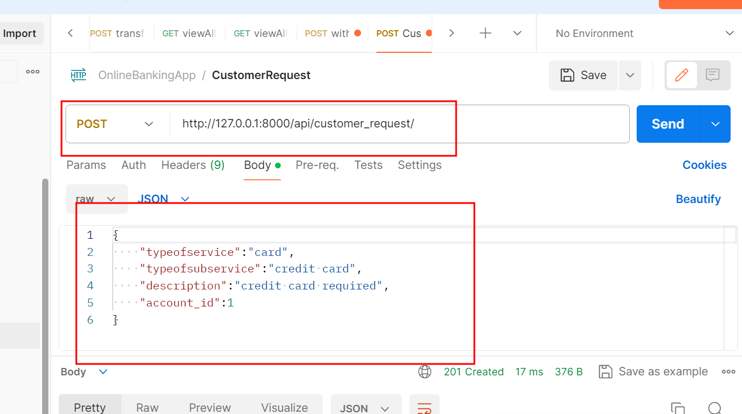

**5.1 : View all customer request**

Method : GET

**URL:** <http://127.0.0.1:8000/api/customer_request/>

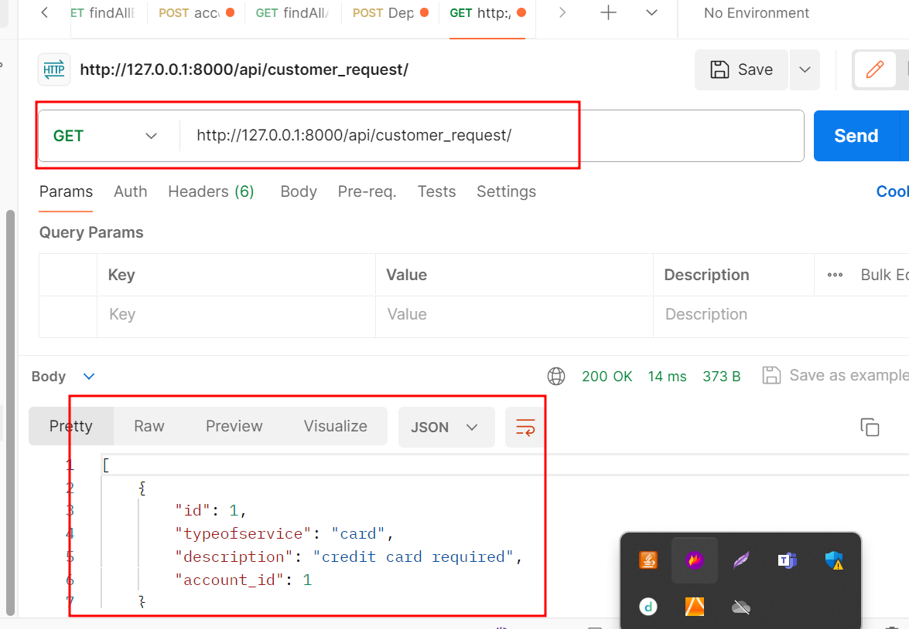

**5.2 : Sign after account created**

Method : POST

**URL:** <http://127.0.0.1:8000/api/signin_account/>

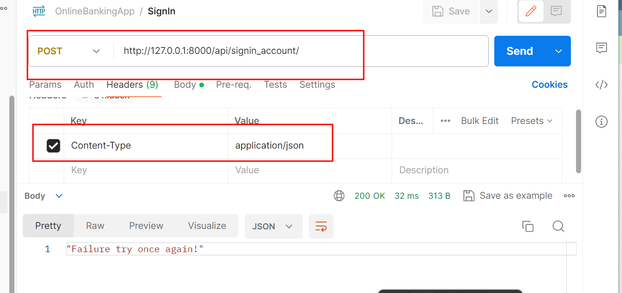

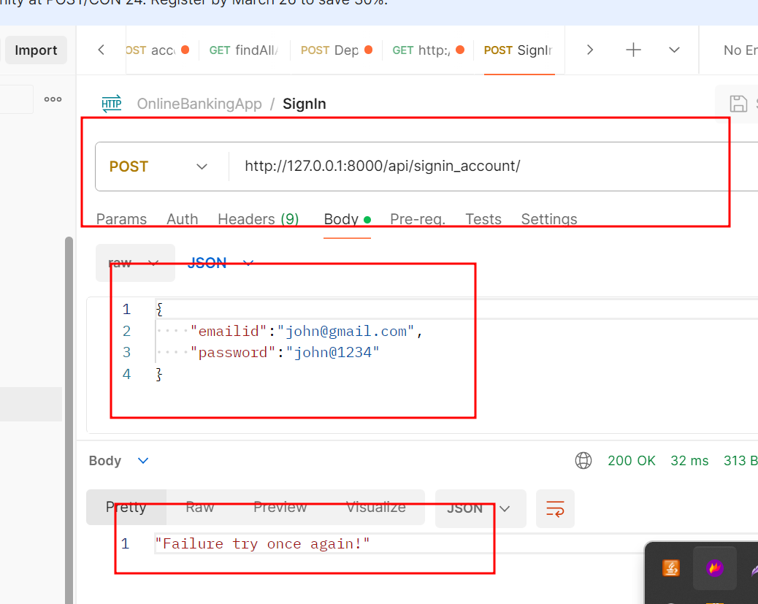

**With success message**

